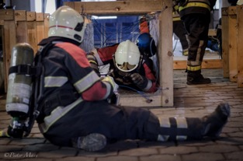
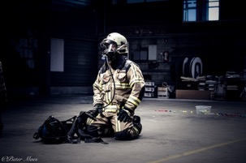
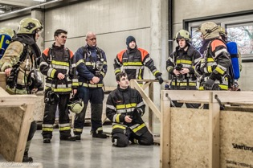
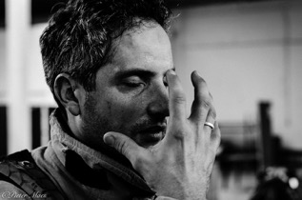
1st. Fireground Survival Seminar

Fireground Survival Seminar & Symposium
  - Uw familienaam
1st Int.l 4-day seminar about Fireground Survival. This training will improve your SCBA functionality no matter what level of experience you have. Every firefighter is welcome. The program is designed to adapt to the participant. For every 5 participants there is 1 instructor. This program covers basic SCBA skills that you don’t know about yet as well as advanced Fireground Survival skills. We will cover the Mayday, orientation and localization based on sectorization, dealing with collapse situations, dealing with respiratory stress, forcible entry & exit and many more… Register now with the document included. Places are limited!  1st Int. Fireground Survival Symposium  During this symposium we focus on Fireground Survival in its broadest sence. Covering from individual techniques and experience to visionary visions on implementation of new policies. Our speakers will share experiences and provide new insights. Already now we can announce chief Bert Brugghemans (Antwerp Fire Department), Ed Oomes (Crisis Programmanager Schiphol Airport & safety blogger), battalion chief Thomas Gruber (Frankfurt Fire Department & Frankfurt Fire Academy) and many others! Check the document included to make sure you have a seat! |  | Maintaining situational awareness while dealing with stressfull situations is one of the learning domains during our seminar.  What can we change and how do we start the change to improve safety on the fireground? Let’s look beyond the policies and intentions. We will talk how to put things in place. Things you can take home!

Seminar Registration Form
(for the symposium see end of document)

Please fill out one form per participant. Send your filled out form to info@brandweermaninnood.be
PERSONAL INFORMATION
Name: ………………………………………………………………………………………………………………………………………………………..
Organisation / department:……..……………………………………………………………………………………………………………….
Street & nr: ………………………………………………………………………………………………………………………………………………
City & postal code: ………………………….……………………………………………………………………………………………………….
Country: …………………………………………………………. Email: ……………………………………………………………………………
Phone: ………………………………………………………………VAT: .…………………………………………………………………………….

REGISTRATION
I hereby wish to register for the 4-day Fireground Survival Seminar (18th till 21nd of September 2018) organized by the Firefighter Mayday Program. I agree to pay €900,00 registration fee (VAT included) before September 1st 2018.Payements before August 1st receive 10% reduction on the registration fee. Payment instructions below.
- I register for the seminar and pay before august 1st 2018: €810,00 YES NO
- I register for the seminar and pay after August 1st 2018: €900,00 YES NO
Name: ………………………………………………………… Signature & date: ………………………………………………………….
Payment info:
- Receiving party: VUUR VOF, Oplinterstraat 80, 3350 Belgium.
- Bank account IBAN: BE12 9730 8571 5092 BIC: ARSPBE22
- Paypall: www.paypall.me/VUURVOF
- Message: 2018 FGS Seminar “name”
Cancelling at least 4 weeks before the start of the event = 90% of the fee is paid back.
Cancelling later than 4 weeks before the start 75% of the fee is paid back.

SCBA / BREATHING APPARATUS.
Every participant must bring his personal SCBA / breathing apparatus and 2 bottles. Participants who come by plane and who can not bring their own SCBA / breathing apparatus have acces to a limited amount of SCBA that are available free of cost. To assign these SCBA’s that are free of cost we will honor the first come / first served principle. We will do our best to obtain as many SCBA as possible free of charge. Please indicate below if we need to provide an SCBA for you or not:
YES I need an SCBA NO I will bring my own SCBA + 2 bottles.

LODGING / HOTEL
Untill the 1st August it is possible to book a room in the Hostel ‘Bed Muzet’ in Lier (7km from the fire academy). After August 1st we can no longer take care of your lodging. We organize daily transport from the Hostel to the fire academy by bus. Please indicate if you want to book a room. The price of the room in not included in the fee for the seminar. The reservation is made for a stay from the 17th of September till the morning of the 21st of September.
For information about the hostel check: https://www.jeugdherbergen.be/en/lier
- I wish to book a comfort multi person room: €27,50€ per night, including breakfast. YES NO
- I wish to book a comfort twin person room: €32,00€ per night, including breakfast. YES NO
- I wish to book a comfort single person room: €45,50€ per night, including breakfast. YES NO
- I wish to book a 3-course dinner for every evening: €16,00 per person per day. YES NO
Please indicate below if you have any specific requests concerning food allergies.

…………………………………………………………………………………………………………………………………………………………………
Name: ………………………………………………………… Signature & date: ………………………………………………………….
Due to logistical reasons we can not book any other arrangements.
The invoice for the lodging will be mailed the beginning of august.

CONTACT INFORMATION
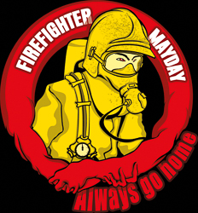
The Firefighter Mayday Program
Mr Pieter Maes
Phone: +32 474 262506
Email: info@brandweermaninnood.be
Website: www.firefightermayday.com

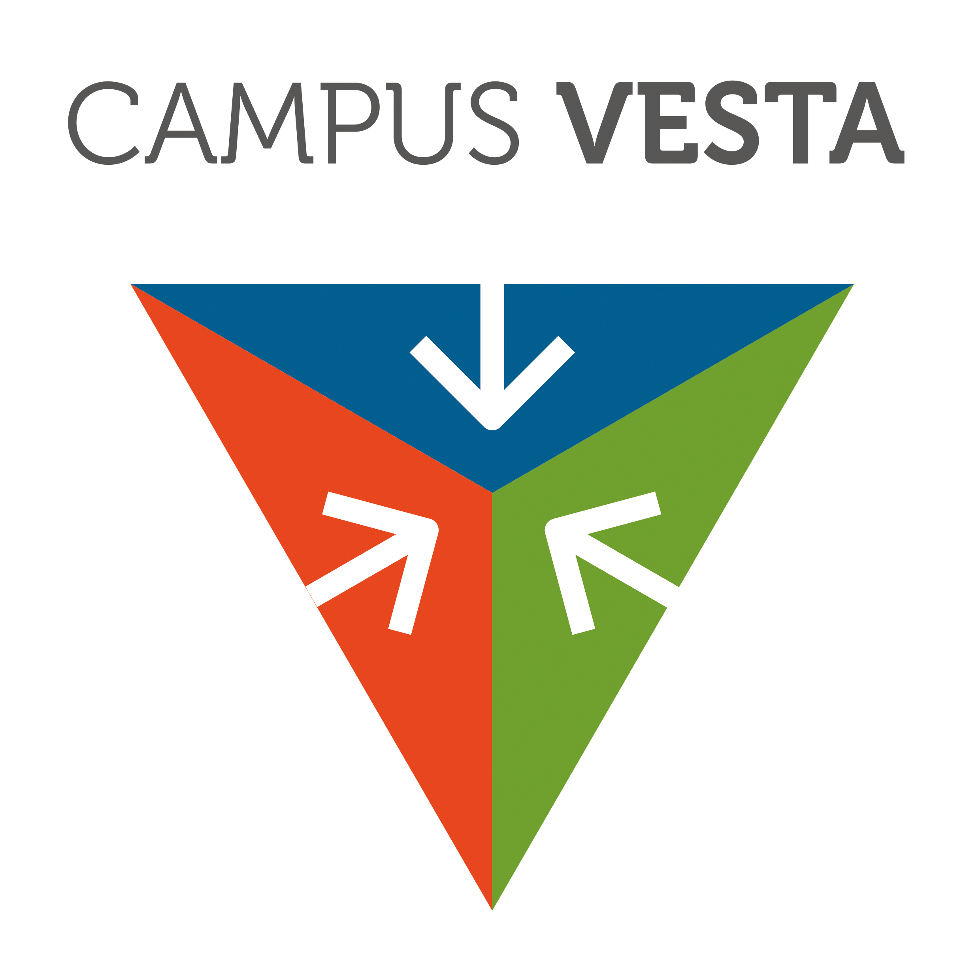
With the support of:
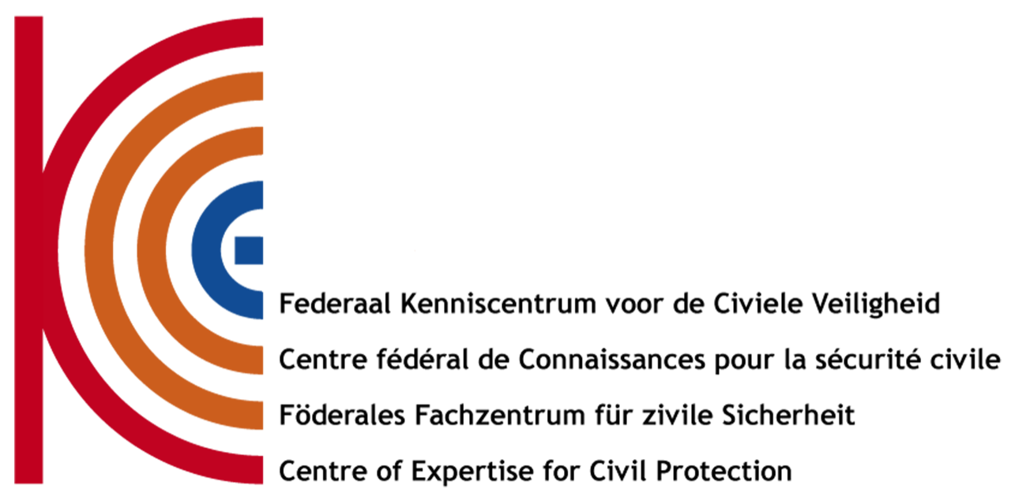

Symposium Registration Form

REGISTRATION
I hereby wish to register for the 1-day Fireground Survival Symposium 22nd of September 2018 organized by the Firefighter Mayday Program. I agree to pay €135,00 registration fee (VAT included) before September 1st 2018.Payements before August 1st receive 10% reduction on the registration fee. Payment instructions below. Particpipants for the Fireground Survival seminar can join the symposium free of charge.
- I register for the symposium and pay before august 1st 2018: €121,50 YES NO
- I register for the symposium and pay after August 1st 2018: €135,00 YES NO
- I am registered for the seminar and wish to also attend the symposium YES NO
Name: ………………………………………………………… Signature & date: ………………………………………………………….
Payment info:
- Receiving party: VUUR VOF, Oplinterstraat 80, 3350 Belgium.
- Bank account IBAN: BE12 9730 8571 5092 BIC: ARSPBE22
- Paypall: www.paypall.me/VUURVOF
- Message: 2018 FGS Symposium “name”
Cancelling at least 4 weeks before the start of the event = 90% of the fee is paid back.
Cancelling later than 4 weeks before the start 75% of the fee is paid back.
PERSONAL INFORMATION
Name: ………………………………………………………………………………………………………………………………………………………..
Organisation / department:……..……………………………………………………………………………………………………………….
Street & nr: ………………………………………………………………………………………………………………………………………………
City & postal code: ………………………….……………………………………………………………………………………………………….
Country: …………………………………………………………. Email: ……………………………………………………………………………
Phone: ………………………………………………………………VAT: .…………………………………………………………………………….

